# CS 255 System Design Document Template

## UML Diagrams

### UML Use Case Diagram

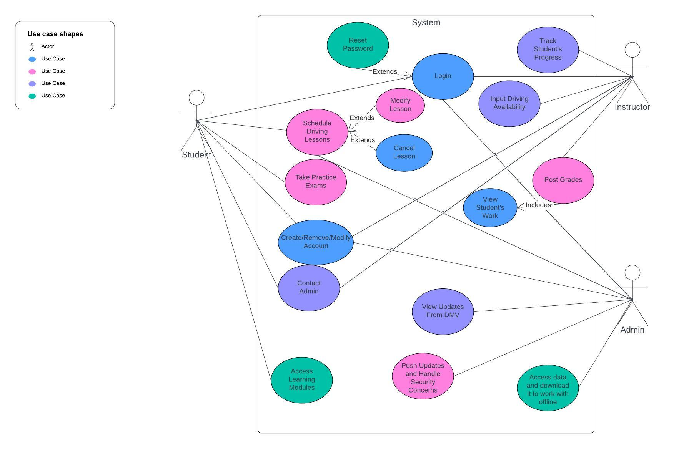

### UML Activity Diagrams

User Login Activity Diagram

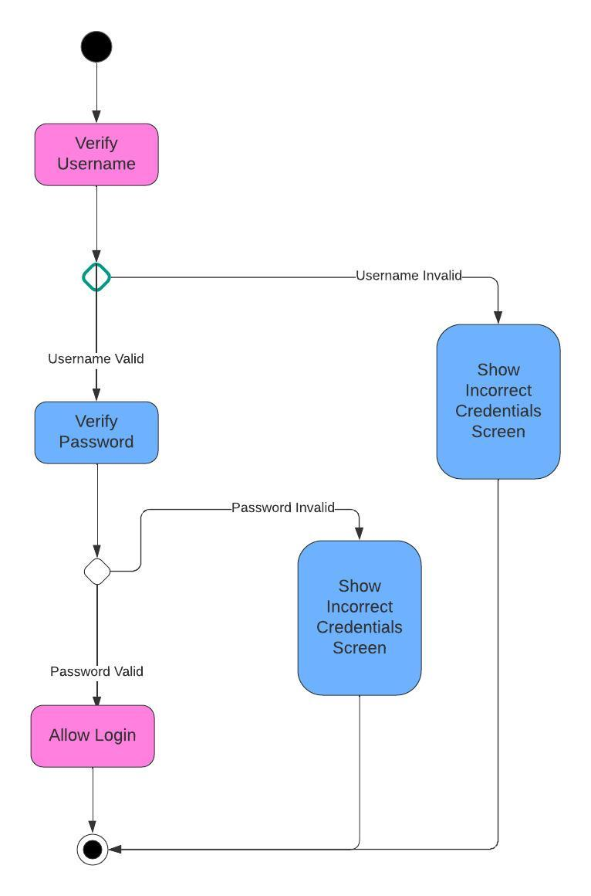

Student Access Learning Modules Activity Diagram

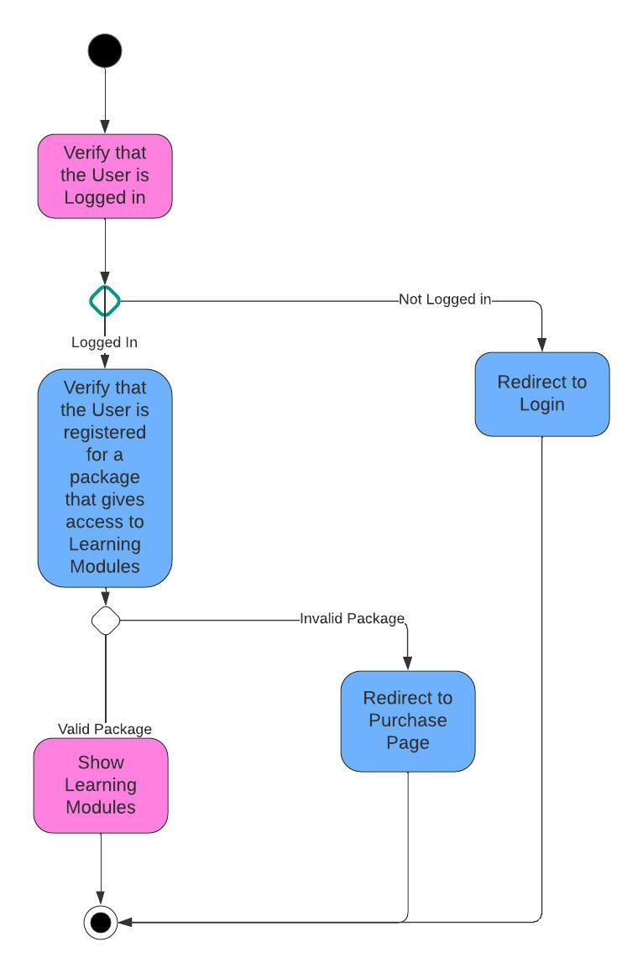

### UML Sequence Diagram

User Login Sequence Diagram

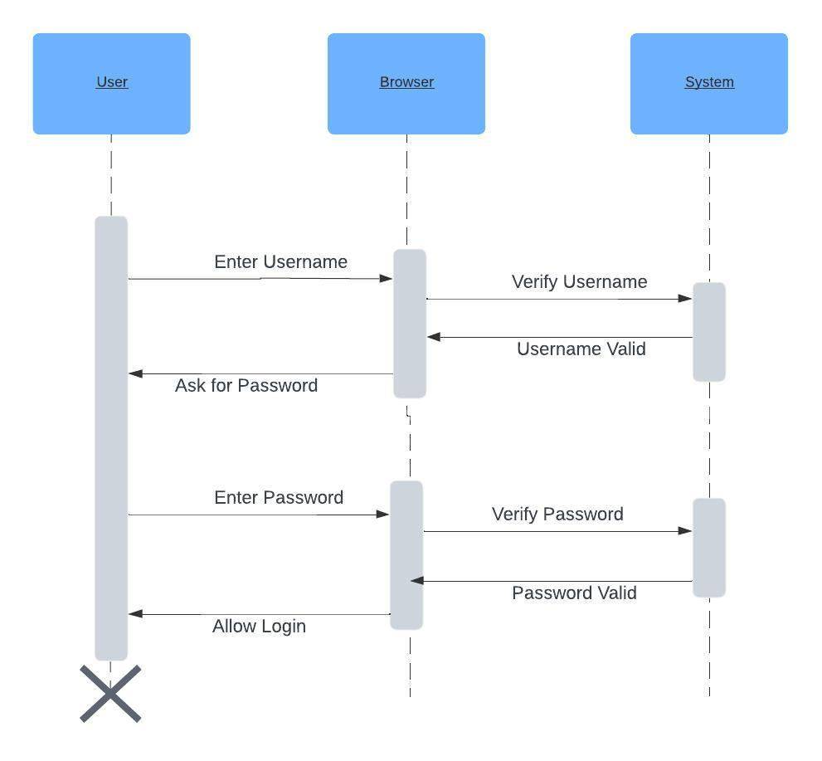

### UML Class Diagram

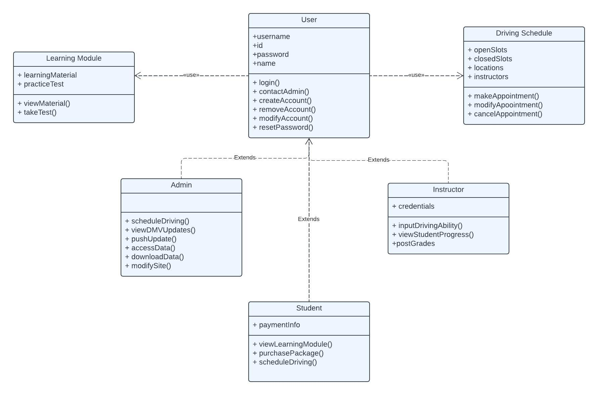

## Technical Requirements

The technical requirements of this system can be divided into hardware and software. The hardware requirements include a device for the user to access the site with. This device could be a laptop, tablet, or PC. The system does not currently include specifications for access from a mobile device, but future update might include that. The system also requires a server to run the back end of the site. This could be a physical server owned by DriverPass or a server rented from a larger corporation such as AWS. The software requirements include an appealing GUI for students and instructors to interact with that includes easy to understand navigation of the site. The software must support the functionality of each use case and an API will be used to access the DMV updates. User’s will also need a web browser in order to access the site.